Disaster Medical Camp CRM
Problem Statement
During natural disasters and humanitarian emergencies, temporary medical camps are established to provide immediate healthcare services to affected populations. However, these camps often depend on manual records, spreadsheets, or disconnected systems, leading to several operational challenges such as:
- Missed or delayed patient follow-ups
- Inefficient doctor allocation across camps
- Poor visibility of patient treatment data
- Limited reporting and monitoring for camp managers and relief agencies
These challenges reduce the effectiveness of healthcare delivery, delay decision-making, and impact transparency during disaster response operations.
To address these issues, this project proposes a Salesforce-based Disaster Medical Camp CRM that centralizes patient, doctor, and camp data into a single platform. The system enables:
- Centralized patient registration and treatment tracking
- Efficient assignment of doctors to patients
- Camp-wise monitoring of healthcare activities
- Automated reporting and dashboards for management
This solution ensures faster response times, improved coordination, and data-driven decision-making in disaster relief medical operations.

Project Objectives
The main objectives of the Disaster Medical Camp CRM are:
- To digitally manage disaster medical camps and healthcare activities
- To maintain structured records of patients and assigned doctors
- To reduce manual effort and errors in emergency healthcare operations
- To provide real-time visibility through reports and dashboards
- To support scalability for multiple camps and high patient volumes

Phase 1: Problem Understanding & Industry Analysis

1. Requirement Gathering
Based on real-world disaster relief healthcare scenarios, the following functional requirements were identified:
Patient Management
- Patient Name, Age, Gender
- Medical condition or diagnosis
- Assigned Doctor
- Camp where treatment is provided
Doctor Management
- Doctor Name and specialization
- Assignment to patients
- Association with disaster camps
Disaster Camp Management
- Camp name and location
- Multiple doctors and patients linked to a camp
Reporting & Monitoring
- Camp-wise patient details
- Doctor-wise patient assignments
- Overall visibility of healthcare activities
📸 Insert screenshots of Custom Objects (Disaster Camp, Doctor, Patient)

2. Stakeholder Analysis
Stakeholder | Responsibilities
Salesforce Admin | Configuration of objects, fields, relationships, and reports
Doctors | View assigned patients and update treatment details
Volunteers | Register patients and assign them to camps and doctors
Camp Manager | Monitor patient and doctor data
Relief Agencies | Access reports for transparency and oversight

3. Business Process Mapping
The overall business process flow of the system is as follows:
Disaster Occurs → Medical Camp Setup → Patient Registration → Doctor Assignment → Treatment → Reporting & Monitoring
This structured process ensures clear accountability and smooth operational flow even during high-pressure disaster scenarios.

4. Industry-Specific Use Case Analysis
- Disaster Relief Environment: Requires rapid data entry and minimal complexity
- Healthcare Constraints: Limited doctors and resources need efficient allocation
- High Data Volume: System must handle multiple camps and patients
- Transparency Needs: Reporting is critical for NGOs and authorities
Salesforce CRM provides a cloud-based, scalable, and reliable platform to meet these requirements effectively.

5. AppExchange Exploration
Several existing solutions were analyzed:
- Salesforce Health Cloud: Too complex and costly for temporary camps
- Clinic/Hospital Management Apps: Designed for permanent healthcare facilities
- Custom Salesforce CRM: Best suited for lightweight, fast, and scalable disaster operations
Therefore, a custom Salesforce CRM application was chosen as the optimal solution.

Why This Project is Simple Yet Impactful
- Uses core Salesforce admin concepts
- Minimal Apex dependency (admin-focused design)
- Socially relevant and real-world applicable
- Easy to demonstrate and explain
- Scalable for future enhancements

Phase 2: Org Setup & Configuration
This phase focuses on preparing the Salesforce environment to support the Disaster Medical Camp CRM application. Proper org setup and configuration ensure that the system is secure, scalable, and ready for customization and data management.

1. Salesforce Edition Selection
For this project, a Salesforce Developer Edition was used. The Developer Edition provides full access to Salesforce CRM features, making it suitable for learning, development, and project demonstrations without licensing cost.
Use Case:
Using Developer Edition allows administrators to create custom objects, fields, reports, and dashboards required for managing disaster medical camps.

2. Company Profile Setup
The organization’s basic profile was configured to represent a disaster relief organization.
Use Case:
Company profile setup helps align the CRM with the organization managing disaster medical camps.
Configured details include:
- Organization name
- Default locale and language
- Time zone

3. Business Hours & Holidays
Business hours define the operational working time of the organization.
Use Case:
Although disaster medical camps operate under emergency conditions, standard business hours are configured to support reporting, scheduling, and future automation like reminders or alerts.
- Default business hours were used
- Holidays can be added in the future for reporting purposes

4. Fiscal Year Settings
The standard fiscal year provided by Salesforce was used for this project.
Use Case:
Fiscal year settings help in generating reports and dashboards that track activities and performance over time.

5. User Setup & Licenses
The project uses the default system user available in the Developer Edition org.
Use Case:
A single admin user is sufficient for development and demonstration purposes. In a real-world scenario, multiple users such as doctors, volunteers, and managers can be created with different roles.

6. Login Access Policies
Default Salesforce login policies were retained.
Use Case:
Salesforce provides built-in security features such as password policies and session management, ensuring secure access to the CRM system.

7. Development Org Setup
A dedicated Salesforce Developer Org was used exclusively for building this project.
Use Case:
Using a development org ensures:
- Safe experimentation
- No impact on production data
- Easy reset and modification during learning
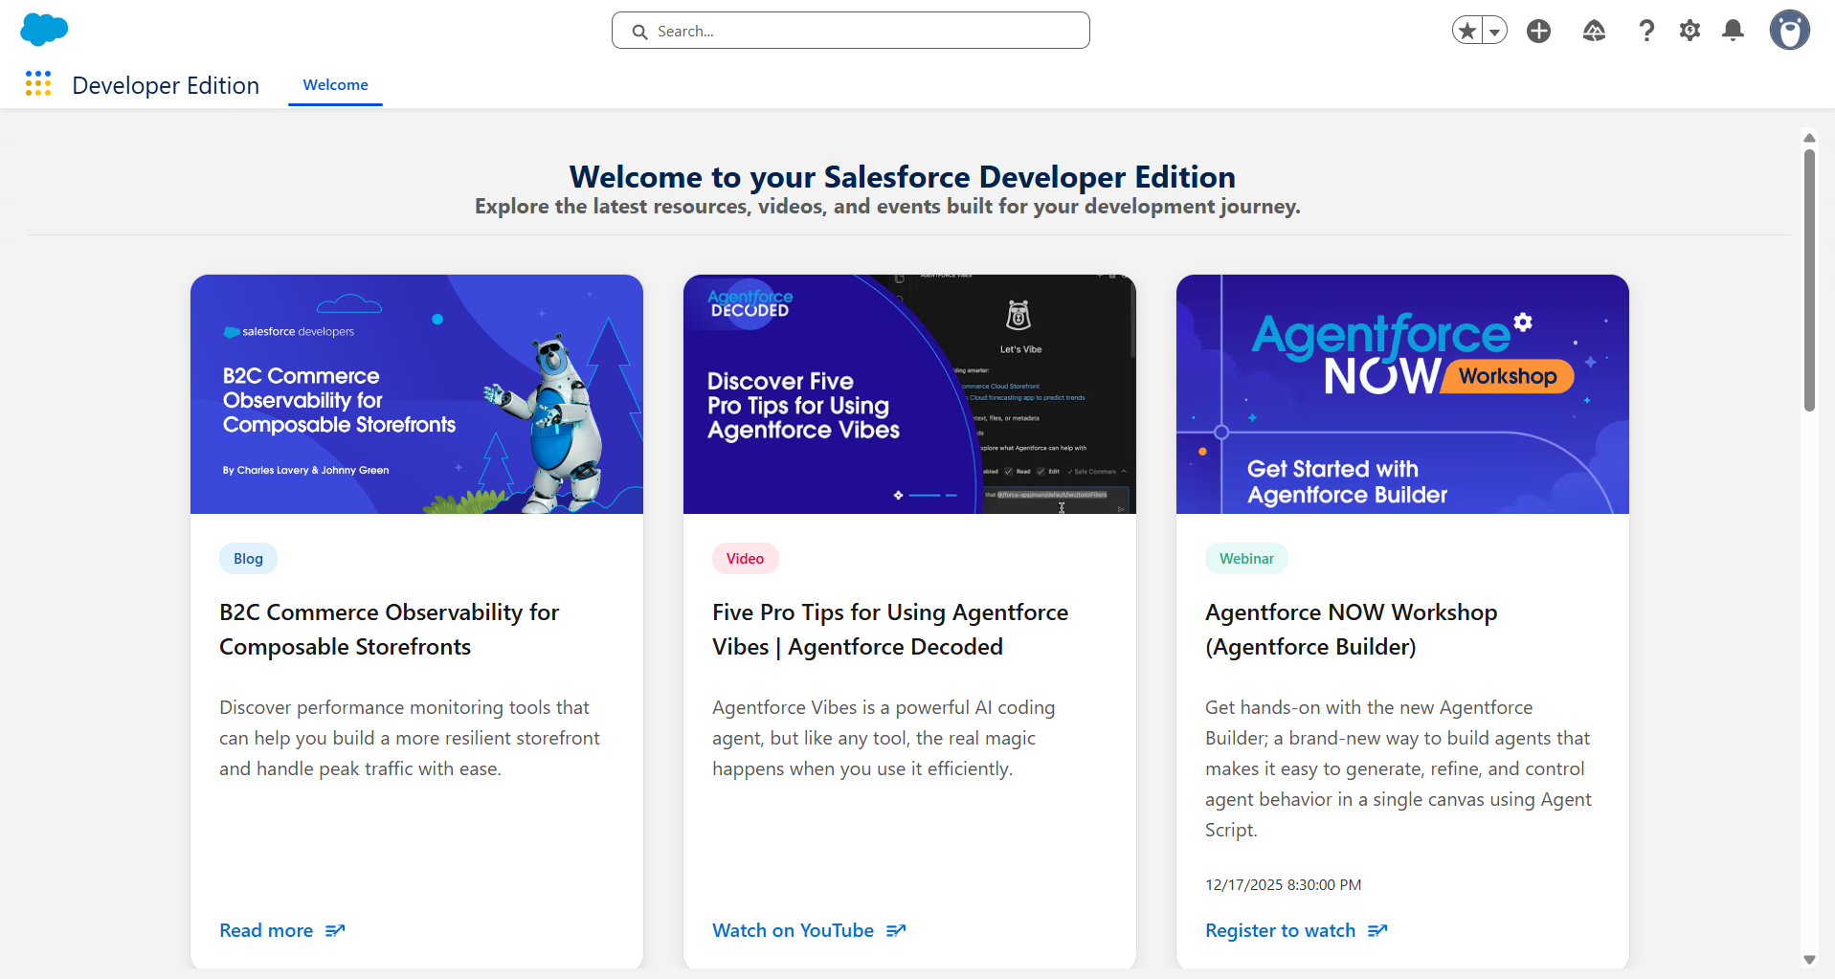
8. Sandbox Usage
No sandbox was used for this project.
Justification:
Since this is a learning and demonstration project developed in a Developer Edition org, all configurations were done directly in the same environment.

9. Deployment Basics
Deployment was not required for this project as it was developed and demonstrated within a single Salesforce org.

Phase 3: Data Modeling & Relationships
This phase focuses on designing the data structure of the Disaster Medical Camp CRM. Proper data modeling ensures efficient storage, retrieval, and relationship management between disaster camps, doctors, and patients.

1. Standard & Custom Objects
Salesforce standard objects alone were insufficient to represent disaster relief operations. Therefore, custom objects were created.
Custom Objects Created:
- Disaster Camp
  - Represents temporary medical camps set up during disasters.
- Doctor
  - Stores information about doctors and medical staff assigned to camps.
- Patient
  - Stores patient registration, diagnosis, and treatment details.
Use Case:
Custom objects allow the CRM to manage disaster-specific data that is not supported by standard Salesforce objects.

2. Fields
Each custom object includes relevant fields to capture required information.
Disaster Camp Fields
- Disaster Camp Name (Text – Standard Name field)
- Location (Text)
- Camp Start Date (Date)
- Camp End Date (Date)
Doctor Fields
- Doctor Name (Text – Standard Name field)
- Specialization (Text)
- Phone (Phone)
- Assigned Camp (Lookup to Disaster Camp)
Patient Fields
- Patient Name (Text – Standard Name field)
- Age (Number)
- Gender (Picklist)
- Assigned Doctor (Lookup to Doctor)
- Camp (Lookup to Disaster Camp)
Use Case:
Fields capture structured data required for treatment tracking, doctor assignment, and reporting.
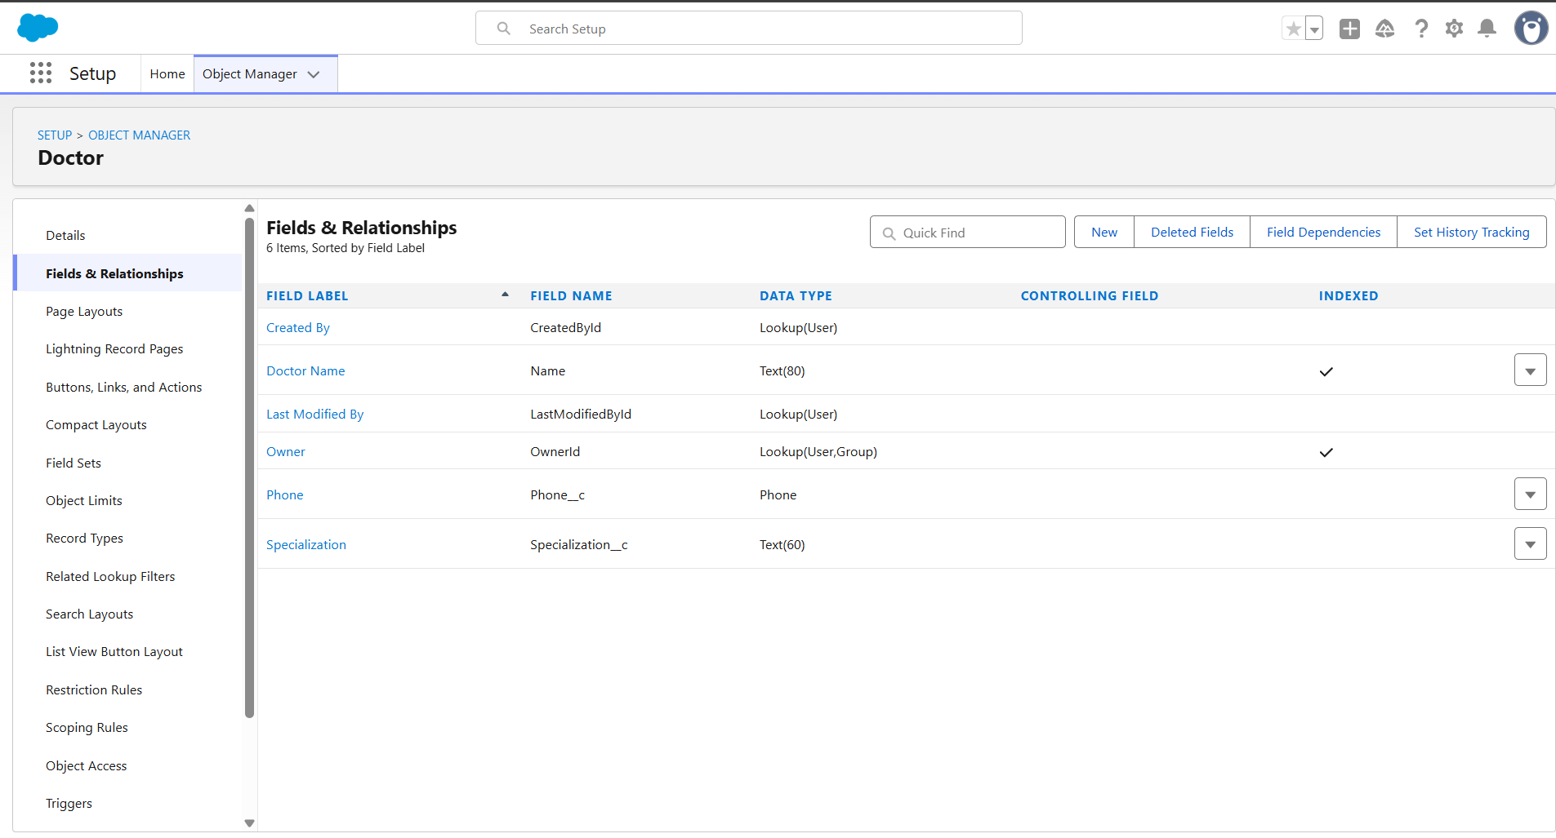
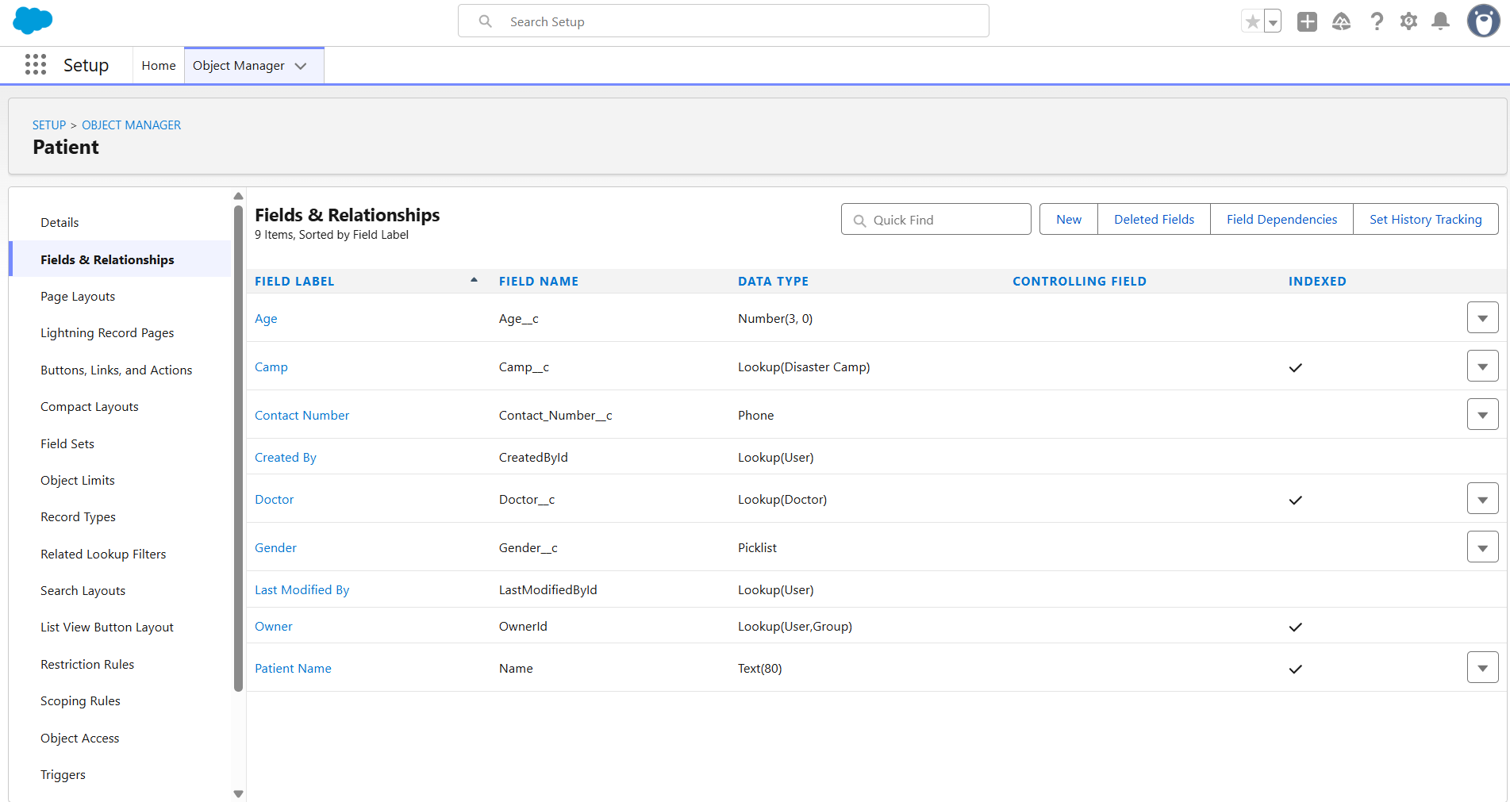

3. Record Types
Record Types were not implemented in this phase.
Justification:
The current scope of the project does not require multiple business processes within the same object. A single record type is sufficient for managing disaster camp data.

4. Page Layouts
Custom page layouts were configured for each object.
Patient Page Layout
- Patient Details section
- Doctor assignment field
- Camp assignment field
- Medical information fields grouped logically
Doctor Page Layout
- Doctor information
- Assigned camp
- Related patients section
Use Case:
Page layouts improve usability by organizing fields clearly for faster data entry.
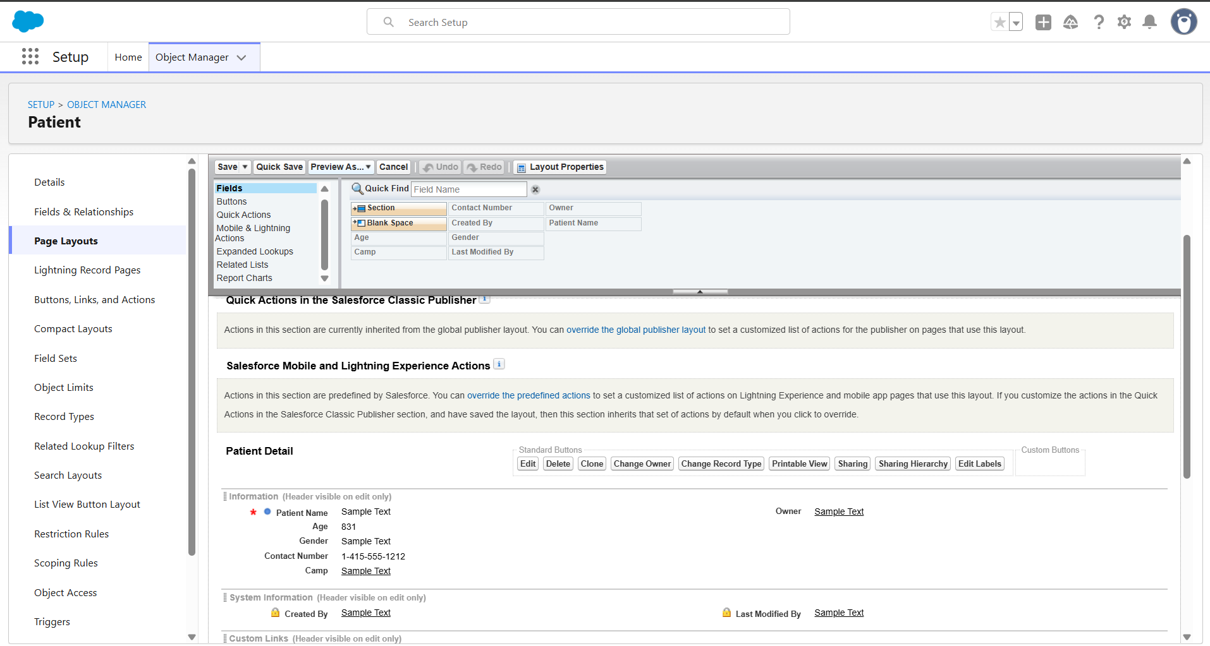
5. Compact Layouts
Compact layouts were not customized.
Justification:
Default compact layouts are sufficient for this project and support record highlights in Lightning Experience.

6. Schema Builder
Schema Builder was used to visually verify object relationships.
Use Case:
Schema Builder provides a clear graphical representation of how Disaster Camp, Doctor, and Patient objects are connected.

7. Relationships
Lookup Relationships Implemented
- Doctor → Disaster Camp
  - Each doctor is assigned to one disaster camp.
- Patient → Doctor
  - Each patient is assigned to one doctor.
- Patient → Disaster Camp
  - Each patient is linked to the camp where treatment is provided.
Use Case:
Lookup relationships provide flexibility, allowing records to exist independently if needed.

8. Lookup vs Master-Detail vs Hierarchical Relationships
- Lookup Relationship was chosen over Master-Detail.
- Hierarchical relationships were not required.
Justification:
Lookup relationships allow independent record management and avoid automatic record deletion if a related record is removed.

9. Junction Objects
Junction objects were not implemented.

10. External Objects
External objects were not used.

Phase 4: Process Automation (Admin)
This phase focuses on automating key business processes in the Disaster Medical Camp CRM to reduce manual effort, ensure data accuracy, and improve operational efficiency during emergency situations.

1. Validation Rules
Validation rules were implemented to ensure that critical data is always captured before saving records.
Validation Rule Use Cases
Patient Record Validation
  - Ensures that mandatory fields such as Camp are filled before saving a Patient record.
Use Case:
Prevents incomplete patient registrations, which is critical during disaster medical operations.
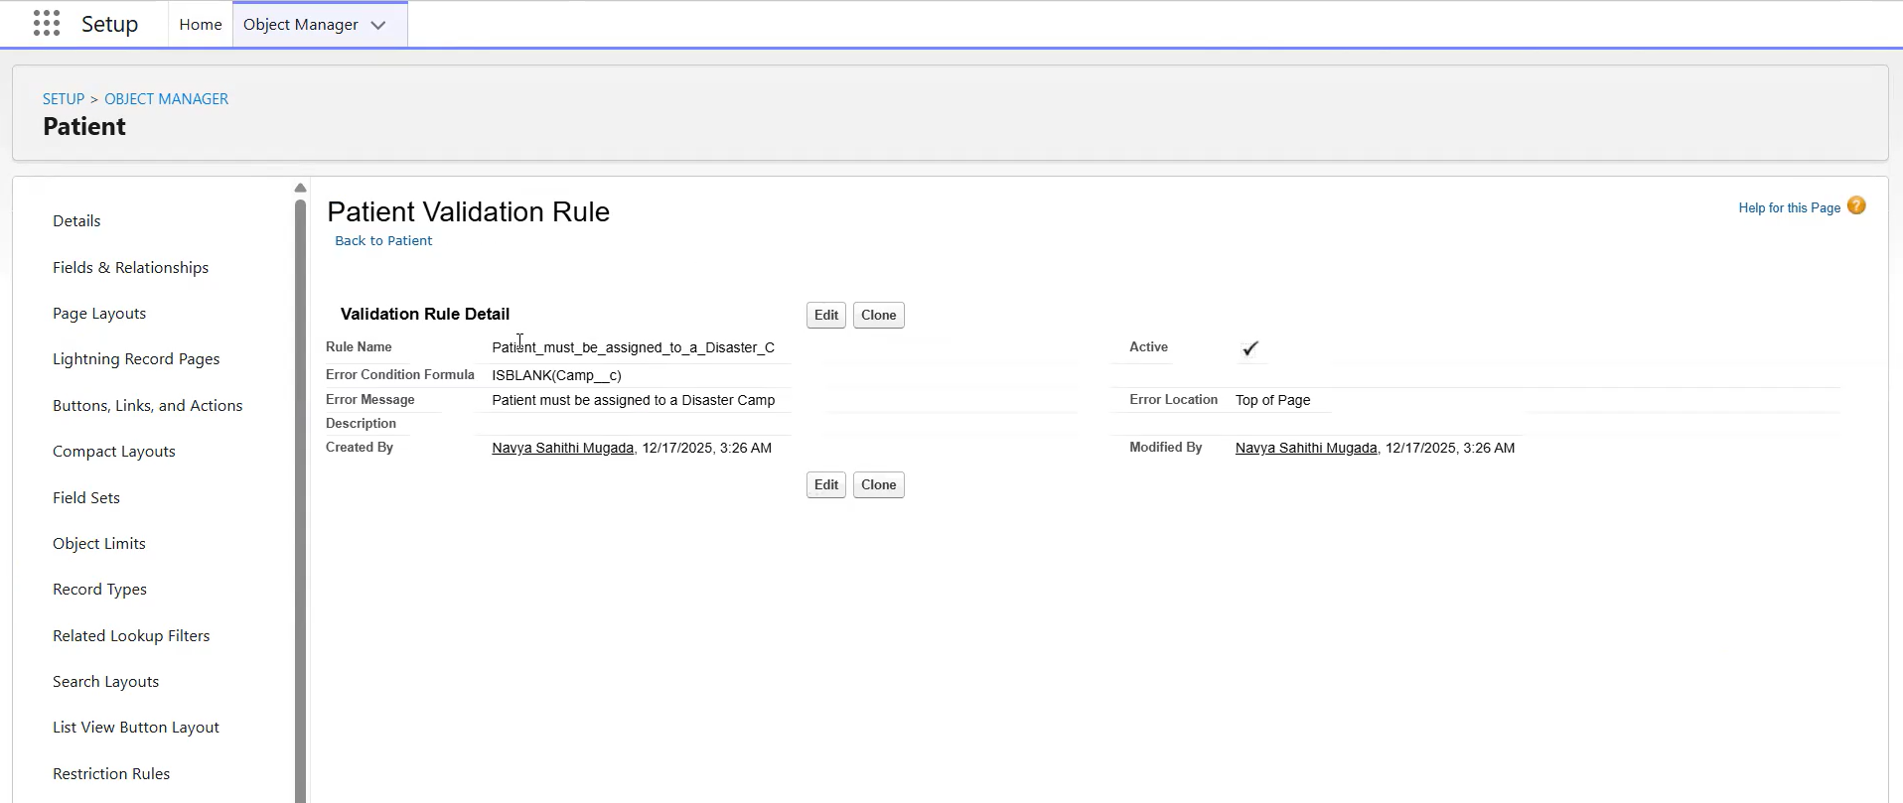
Field Updates
Field updates were handled through Flow logic.
Use Case:
Future enhancements can include automatic status updates (e.g., “Under Treatment”, “Recovered”).

Workflow Rules, Process Builder, Approval Process, Email Alerts, Custom Notifications were not used in this project.

Phase 5: Apex Programming (Developer)
This phase focuses on server-side programming using Apex to handle complex business logic, asynchronous processing, and advanced automation.
However, for the Disaster Medical Camp CRM, Apex programming was not implemented in the current version of the project.
Although Apex was not implemented in the current phase, it can be added in future versions for:
- Automatic doctor assignment based on workload
- Bulk patient processing during large-scale disasters
- Scheduled data cleanup and archival
- Integration with external hospital or government systems

Phase 6: User Interface Development
This phase focuses on designing a user-friendly interface using Salesforce Lightning Experience. The goal is to ensure that doctors, volunteers, and administrators can easily navigate and use the Disaster Medical Camp CRM during emergency situations.

1. Lightning App Builder
A custom Lightning App named “Disaster Medical Camp CRM” was created using Salesforce App Manager.
Use Case:
The custom app groups all relevant objects such as Disaster Camps, Doctors, Patients, Reports, and Dashboards into a single workspace, improving accessibility and productivity.
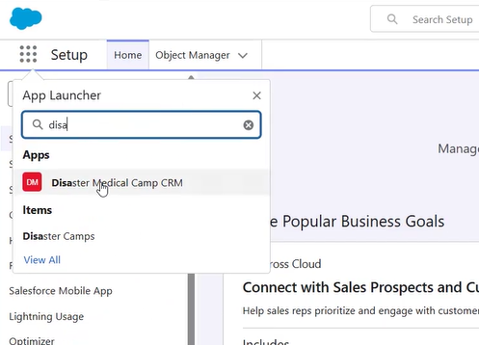
2. Record Pages
Standard Lightning Record Pages were used for all custom objects.
Objects Covered:
- Disaster Camp
- Doctor
- Patient
Use Case:
Record pages display key information such as patient details, assigned doctor, and camp location in a structured manner.

3. Tabs
Custom tabs were created for all custom objects.
Tabs Created:
- Disaster Camps
- Doctors
- Patients
Use Case:
Tabs allow users to quickly access records without navigating through Setup or Object Manager.
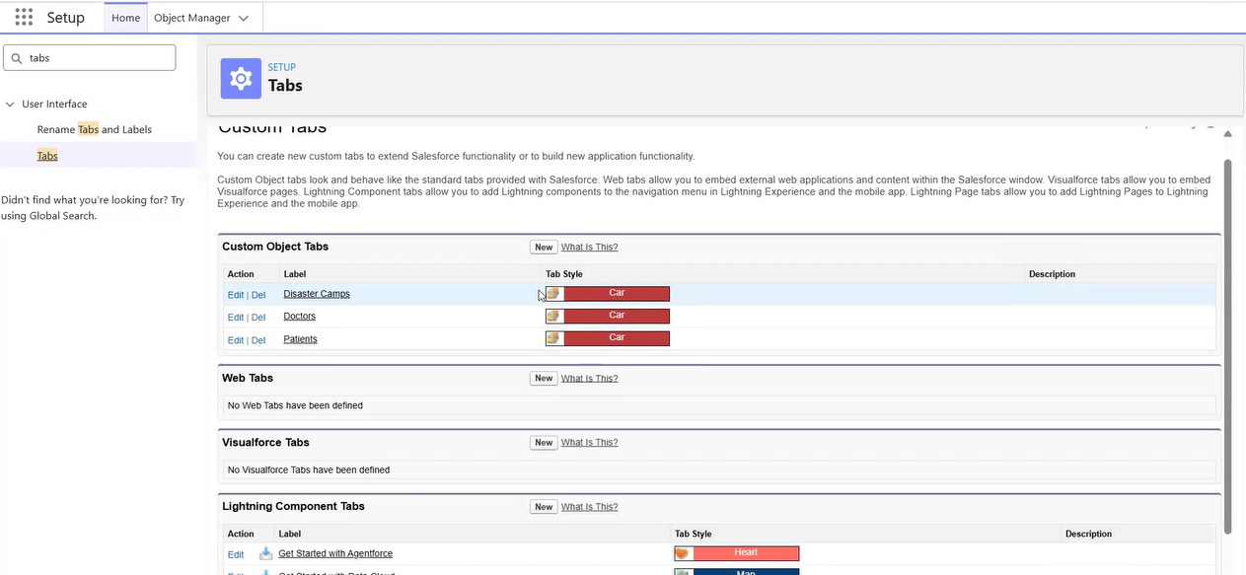
4. Home Page Layouts
The default Salesforce Home page was used.
Use Case:
The Home page provides quick access to recent records, tasks, and reports.
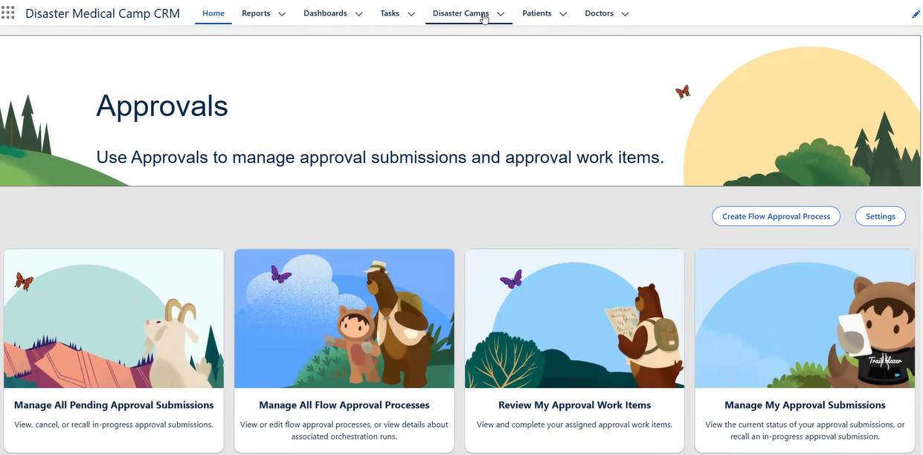
5. Navigation Service
Default Salesforce navigation was used.
Use Case:
Users can navigate seamlessly between Camps, Doctors, Patients, Reports, and Dashboards within the custom app.

6. Utility Bar, Lightning Web Components (LWC), Apex with LWC, Events in LWC, Wire Adapters, Imperative Apex Calls were not implemented.

Phase 7: Integration & External Access
This phase focuses on enabling communication between Salesforce and external systems using APIs, authentication mechanisms, and integration tools. Integrations are typically used to exchange data with external healthcare systems, government databases, or logistics platforms.
For the Disaster Medical Camp CRM, external integrations were not implemented in the current project scope.

Phase 8: Data Management & Deployment
This phase focuses on managing data efficiently within Salesforce and understanding deployment mechanisms. Proper data management ensures accuracy, avoids duplication, and supports reporting and analytics.

1. Data Import Wizard
The Salesforce Data Import Wizard was used to create and manage records.
Use Case:
Patient, Doctor, and Disaster Camp records were added manually and can also be imported using CSV files for faster bulk data entry during large-scale disasters.

2. Data Loader, Duplicate Rules, Data Export & Backup, Change Sets, Unmanaged vs Managed Packages, ANT Migration Tool, VS Code & Salesforce DX were not used in this project.

Phase 9: Reporting, Dashboards & Security Review
This phase focuses on analyzing data through reports and dashboards and reviewing security configurations to ensure controlled access to sensitive medical information.

1. Reports
Salesforce reports were created to analyze data captured in the Disaster Medical Camp CRM.
Report Types Used
- Custom Object Reports
Sample Reports Created
- Patients by Disaster Camp
- Patients Assigned to Doctor
Use Case:
Reports help camp managers monitor patient load, doctor assignments, and overall camp performance.
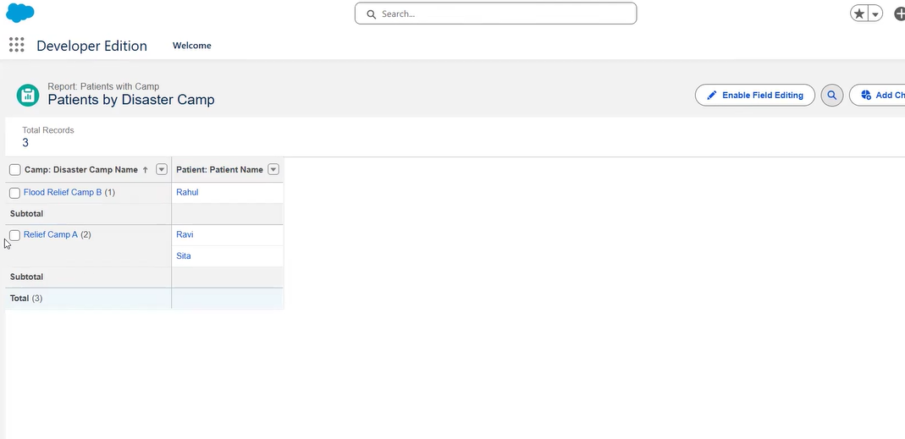

2. Report Formats
The following report format was used:
- Tabular Report
Justification:
Tabular reports are simple and effective for quick viewing and exporting data.

3. Dashboards
A basic dashboard was created using the above reports.
Use Case:
Dashboards provide a visual summary of:
- Total patients
- Doctor distribution
- Camp-wise activity
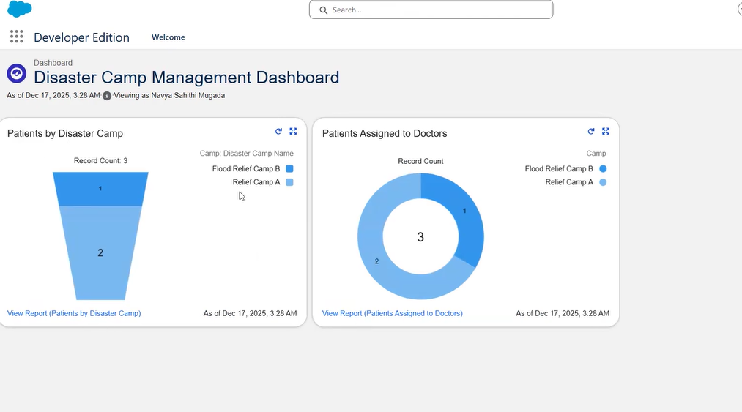
4. Dynamic Dashboards
Dynamic dashboards were not implemented.
Justification:
Single-user development environment does not require role-based dynamic views.

5. Profiles
Standard Salesforce profiles were used.
Profiles Used:
- System Administrator
- Standard User (conceptually)
Use Case:
Profiles define object-level access and permissions.

6. Roles
Role hierarchy was not configured.
Justification:
The project uses a single-user setup. Role hierarchy can be added in real-world deployments.

7. Users
Only one active user (Admin) was used.
Use Case:
Sufficient for development and demo purposes.

8. Permission Sets
Permission Sets were not created.

9. Organization-Wide Defaults (OWD)
Default sharing settings were used.
Use Case:
Ensures baseline data visibility across users.

10. Sharing Rules
Sharing rules were not configured.

11. Field-Level Security
Field-level security was managed through default profile settings.
Use Case:
Controls visibility of sensitive patient information.

12. Session Settings
Default session settings were retained.
Use Case:
Ensures secure user sessions.

13. Login IP Ranges
Login IP ranges were not restricted.

Phase 10: Quality Assurance Testing
This phase ensures that all implemented features of the Disaster Medical Camp CRM are tested thoroughly and presented effectively. Proper testing validates that the system works as expected, while the final presentation demonstrates the project’s functionality and business value.

1. Quality Assurance Testing
Testing was performed manually to verify the correct functioning of all implemented Salesforce features.
Testing Approach
- Manual testing using sample data
- Each feature was tested by creating, updating, and viewing records
- Screenshots were captured for both input and output

2. Test Cases
Test Case 1: Disaster Camp Record Creation
- Use Case: Create a new Disaster Camp
- Test Steps (Input):
  - Enter Camp Name, Location, Start Date
  - Save the record
- Expected Result:
  - Disaster Camp record is successfully created
- Actual Result:
  - Disaster Camp record created successfully

Test Case 2: Doctor Assignment to Camp
- Use Case: Assign Doctor to Disaster Camp
- Test Steps (Input):
  - Create a Doctor record
  - Select Assigned Camp
- Expected Result:
  - Doctor is linked to the selected camp
- Actual Result:
  - Doctor successfully assigned to camp

Test Case 3: Patient Registration
- Use Case: Register a new Patient
- Test Steps (Input):
  - Enter Patient details (Name, Age, Gender)
  - Assign Doctor and Camp
- Expected Result:
  - Patient record saved successfully
- Actual Result:
  - Patient record created successfully

Test Case 4: Validation Rule Execution
- Use Case: Prevent incomplete patient records
- Test Steps (Input):
  - Try saving Patient record without Assigned Doctor
- Expected Result:
  - Error message displayed
- Actual Result:
  - Validation error shown as expected

Test Case 5: Automated Task Creation
- Use Case: Auto-create follow-up task
- Test Steps (Input):
  - Create a new Patient record
- Expected Result:
  - Task is automatically created
- Actual Result:
  - Task created successfully

Test Case 6: Reports Generation
- Use Case: View Patients by Camp report
- Test Steps (Input):
  - Open report
- Expected Result:
  - Report displays correct data
- Actual Result:
  - Report displayed successfully

The Disaster Medical Camp CRM successfully addresses key challenges faced during disaster relief operations. By leveraging Salesforce’s declarative capabilities, the system enables efficient patient tracking, doctor assignment, automation, and reporting. The project demonstrates how Salesforce CRM can be used as a powerful and socially impactful solution for humanitarian healthcare management.

